EXPERIMENT 4: QUARTERLY SALES ANALYSIS
Aim: To calculate the total annual sales and percentage increase in sales using NumPy.
Algorithm:
- Import the NumPy library.
- Create an array of quarterly sales.
- Calculate total sales and percentage increase.
- Display the results.
Code:
import numpy as np
sales_data = np.array([10000, 12000, 15000, 18000])
total = np.sum(sales_data)
increase = ((sales_data[3] - sales_data[0]) / sales_data[0]) * 100
print("Total Annual Sales:", total)
print("Percentage Increase:", increase, "%")
Input:
Sales = [10000, 12000, 15000, 18000]

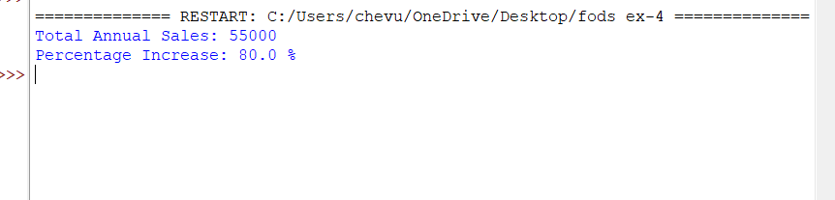
Output:
Result: Thus, the total annual sales are 55,000, and the percentage increase from the first quarter to the fourth quarter is 80%.

